The try statement allows you to define a block of code to be tested for errors while it is being executed.
The catch statement allows you to define a block of code to be executed, if an error occurs in the try block.
The try and catch keywords come in pairs:
try {
// Block of code to try
}
catch(Exception e) {
// Block of code to handle errors
}

Try-with-resources (Java 7+)

What is try-with-resources?
try-with-resources is a Java feature (introduced in Java 7) that automatically closes resources when the try block finishes.
A resource is any object that implements AutoCloseable (or Closeable).

Why was it introduced?
Before Java 7:
Developers had to manually close resources
Often forgotten
Caused resource leaks
Required finally blocks
try-with-resources eliminates these problems.

Basic Syntax
try (FileInputStream fis = new FileInputStream("a.txt")) {
// use resource
} catch (IOException e) {
e.printStackTrace();
}
No finally needed.

How it Works Internally
Resource is created in try(...)
JVM ensures close() is called
close() is called automatically
Happens even if exception occurs
Under the hood:
fis.close();
is implicitly added by compiler.
Why try-with-resources is better than finally?
“try-with-resources is better because it automatically closes resources, reduces boilerplate code, prevents resource leaks, and handles exceptions safely even when both try and close throw exceptions.”

Multiple Catch in One try (Java 7+)

What is Multi-Catch?
Multi-catch allows you to handle multiple exception types in a single catch block using the pipe symbol |.
Introduced in Java 7

Basic Syntax
try {
int a = 10 / 0;
} catch (ArithmeticException | NullPointerException e) {
System.out.println(e);
}
✔ One catch block
✔ Multiple exception types
✔ Cleaner code

Can we catch multiple exceptions in a single catch block?
“Yes, from Java 7 onwards, we can catch multiple exceptions in a single catch block using the | operator, provided the exceptions are not in the same inheritance hierarchy.”

Finally
The finally statement lets you execute code, after try...catch, regardless of the result:
public class Main {
public static void main(String[] args) {
try {
int[] myNumbers = {1, 2, 3};
System.out.println(myNumbers[10]);
} catch (Exception e) {
System.out.println("Something went wrong."); // custom error
System.out.println(e); // Prins exact Exception msg.
} finally {
System.out.println("The 'try catch' is finished.");
} } }
The output will be:
Something went wrong.
The 'try catch' is finished.

final | finally | finalize
final is the keyword and access modifier which is used to apply restrictions on a class, method or variable. | finally is the block in Java Exception Handling to execute the important code whether the exception occurs or not. | finalize is the method in Java which is used to perform clean up processing just before object is garbage collected.

Rule 1: finally executes even if return exists
Rule 2: finally executes even if exception is thrown
Rule 3: finally executes even if exception is caught
Rule 4: finally executes even if return is in catch
Rule 5 (VERY TRICKY): finally can OVERRIDE return
static int test() {
try {
return 10;
} finally {
return 20;
}
}
Output
20📌 finally return overrides try return
❌ Very bad practice
Rule 6: finally executes even if throw exists
try {
throw new RuntimeException();
} finally {
System.out.println("Runs");
}
✔ Runs before exception propagates

When finally does NOT execute (RARE)

finally does NOT run if:
JVM crashes
System.exit() is called
Power failure
try {
System.exit(0);
} finally {
System.out.println("Will NOT run");
}
❌ finally skipped

finally with try-with-resources
try (FileInputStream fis = new FileInputStream("a.txt")) {
// use file
} finally {
System.out.println("Runs after resource close");
}
Resource closes before finally runs
Does finally execute after return?
Yes. The finally block executes even if a return statement is present in the try or catch block, unless the JVM terminates abruptly.

throw keyword
The throw statement allows you to create a custom error.
The throw statement is used together with an exception type. There are many exception types available in Java: ArithmeticException, FileNotFoundException, ArrayIndexOutOfBoundsException, SecurityException, etc:
Example
Throw an exception if age is below 18 (print "Access denied"). If age is 18 or older, print "Access granted":
public class Main {
static void checkAge(int age) {
if (age < 18) {
throw new ArithmeticException("Access denied - You must be at least 18 years old.");
} else {
System.out.println("Access granted - You are old enough!");
} }
public static void main(String[] args) {
checkAge(15); // Set age to 15 (which is below 18...) } }
The output will be:
Exception in thread "main" java.lang.ArithmeticException: Access denied - You must be at least 18 years old.
at Main.checkAge(Main.java:4)
at Main.main(Main.java:12)

to maintain the normal flow of the application.
The throw and throws is the concept of exception handling where the throw keyword throw the exception explicitly from a method or a block of code whereas the throws keyword is used in signature of the method.

public static int divideNum(int m, int n) throws ArithmeticException{ …}

// in method signature
finally | The "finally" block is used to execute the necessary code of the program. It is executed whether an exception is handled or not.
throw | The "throw" keyword is used to throw an exception.
throws | The "throws" keyword is used to declare exceptions. It specifies that there may occur an exception in the method. It doesn't throw an exception. It is always used with method signature

import java.io.*;
class M{
void method()throws IOException{
throw new IOException("device error");
} }
public class Testthrows2{
public static void main(String args[]){
try{
M m=new M();
m.method();
}catch(Exception e){System.out.println("exception handled");}
System.out.println("normal flow...");
} }
Output:
exception handled
normal flow...

throw vs throws

throw | throws
Used inside method body | Used in method signature
Throws ONE exception object | Declares one or more exception types
Used explicitly | Used for exception propagation
Followed by exception object | Followed by exception class names
Used to create exception | Used to declare exception

Can we use throw without throws?
“Yes, we can use throw without throws when throwing unchecked exceptions. For checked exceptions, throws is required unless the exception is handled within the method.”

What is Exception Chaining?
Exception Chaining is a mechanism where:
One exception wraps another exception
Original (root) exception is preserved
Higher layers get meaningful context without losing cause
In short:
Exception inside exception

Why Do We Need Exception Chaining?
Real applications are layered:
DAO layer
Service layer
Controller layer
Lower layers throw low-level exceptions
Upper layers want business-level exceptions
Exception chaining helps:
✔ Preserve root cause
✔ Add meaningful message
✔ Improve debugging

Custom Exception + Chaining
class DataAccessException extends Exception {
DataAccessException(String msg, Throwable cause) {
super(msg, cause);
}
}

try {
connection.commit();
} catch (SQLException e) {
throw new DataAccessException("DB commit failed", e);
}
✔ Database error preserved
✔ Business message added

Exception Chaining vs Suppressed Exceptions
Chaining | Suppressed
One exception wraps another | Secondary exception hidden
getCause() | getSuppressed()
Manual | try-with-resources

What is exception chaining?
“Exception chaining is a mechanism to wrap one exception inside another so that the original cause is not lost while propagating exceptions across application layers.”

Stack Trace Understanding

What is a Stack Trace?
A stack trace is a snapshot of the call stack at the moment an exception occurs.
It shows:
What exception occurred
Which methods were called
In what order
Where the error actually happened

Example Stack Trace
Exception in thread "main" java.lang.ArithmeticException: / by zero
at com.example.Calculator.divide(Calculator.java:10)
at com.example.Service.process(Service.java:20)
at com.example.Main.main(Main.java:5)
Exception Type & Message (TOP LINE)
Call Stack (METHOD CALL ORDER)

Root Cause is at the BOTTOM
at com.example.Main.main(Main.java:5) ← first call
Bottom line = entry point
Top stack frame = where exception occurred
How do you read a stack trace?
“A stack trace shows the sequence of method calls leading to an exception. The top shows where the exception occurred, and the bottom shows the starting point. The root cause can be found by reading the first stack frame or the ‘Caused by’ section.”

Java Exception Propagation

An exception is first thrown from the top of the stack and if it is not caught, it drops down the call stack to the previous method. If not caught there, the exception again drops down to the previous method, and so on until they are caught or until they reach the very bottom of the call stack. This is called exception propagation.
Means if method calling another method has an Exception but the Exception is handled in calling method so this scenario is called Exception Propagation.

Hierarchy of Java Exception classes
The java.lang.Throwable class is the root class of Java Exception hierarchy inherited by two subclasses: Exception and Error. The hierarchy of Java Exception classes is given below:

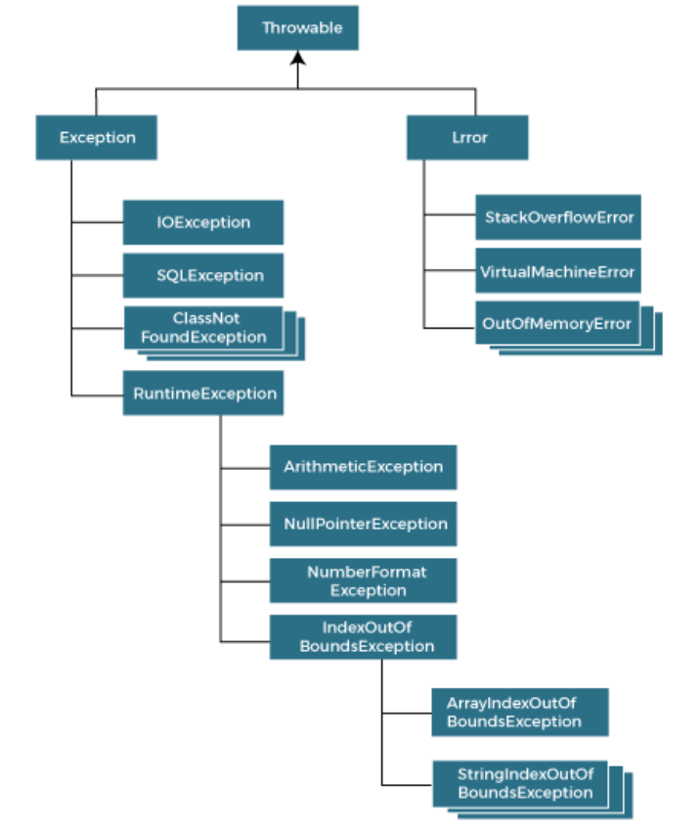

Difference between Checked and Unchecked Exceptions

1) Checked Exception
The classes that directly inherit the Throwable class except RuntimeException and Error are known as checked exceptions. For example, IOException, SQLException, etc. Checked exceptions are checked at compile-time.
Add rules:
Must be handled OR declared
Propagates using throws
Compiler enforces
Why Java introduced checked exceptions?
“Java introduced checked exceptions to force developers to handle recoverable conditions at compile time, making programs more robust and less error-prone.”

2) Unchecked Exception
The classes that inherit the RuntimeException are known as unchecked exceptions. For example,ArithmeticException,NullPointerException,ArrayIndexOutOfBoundsException, etc. Unchecked exceptions are not checked at compile-time, but they are checked at runtime.

3) Error
Error is irrecoverable.
String s=null;
System.out.println(s.length());//NullPointerException

- At a time only one exception occurs and at a time only one catch block is executed.
- All catch blocks must be ordered from most specific to most general, i.e. catch for ArithmeticException must come before catch for Exception.
Exception vs Error

What is an Error?
An Error represents:
Serious system-level problems
Occurs at JVM level
Applications should not try to handle

Examples
OutOfMemoryError
StackOverflowError
NoClassDefFoundError
Exception | Error
Recoverable | Not recoverable
Application-level | JVM / system-level
Can be handled | Should NOT be handled
Extend Exception | Extend Error
Expected scenarios | Unexpected failures

Should we catch Error?
“No, we should not catch Error because it represents serious JVM-level issues from which the application cannot reliably recover.”

Method Overriding & Exceptions
Rules:
Overridden method cannot throw broader checked exception
Parent callers are not aware of new checked exceptions.
Can throw narrower checked exception
void test() throws IOException { } // ✔ narrower //smaller in Hierarchy
Can throw unchecked exceptions freely
Unchecked exceptions are not enforced by compiler.
Can overridden method throw Exception if parent doesn’t?
❌ No.
An overridden method cannot throw a broader checked exception if the parent method does not declare it.

Broader Exception (Parent Exception)
A broader exception is a superclass exception that represents more general problems.
Examples:
Exception is broader than IOException
IOException is broader than FileNotFoundException
Broader = higher in hierarchy

Narrower Exception (Child Exception)
A narrower exception is a subclass that represents more specific problems.
Examples:
FileNotFoundException is narrower than IOException
IOException is narrower than Exception
Narrower = lower in hierarchy

Custom Exceptions in Java

What is a Custom Exception?
A custom exception is a user-defined exception class created to represent application-specific error conditions.
Example:
Invalid age
Insufficient balance
Order not found

Why Do We Need Custom Exceptions?
Built-in exceptions are generic:
NullPointerException
IllegalArgumentException
Custom exceptions make code:
✔ More readable
✔ More meaningful
✔ Easier to debug
✔ Domain-specific

Custom Checked Exception

What is a Checked Exception?
Checked at compile time
Must be handled or declared
Extend Exception

Example: Custom Checked Exception
class InvalidAgeException extends Exception {

InvalidAgeException(String message) {
super(message);
}
}

Using Custom Checked Exception
class Test {
static void validateAge(int age) throws InvalidAgeException {
if (age < 18)
throw new InvalidAgeException("Age must be 18 or above");
}

public static void main(String[] args) {
try {
validateAge(15);
} catch (InvalidAgeException e) {
System.out.println(e.getMessage());
}
}
}
Compiler forces handling → checked

Custom Unchecked Exception

What is an Unchecked Exception?
Checked at runtime
NOT mandatory to handle
Extend RuntimeException

Example: Custom Unchecked Exception
class InvalidAgeRuntimeException extends RuntimeException {

InvalidAgeRuntimeException(String message) {
super(message);
}
}

Using Custom Unchecked Exception
class Test {
static void validateAge(int age) {
if (age < 18)
throw new InvalidAgeRuntimeException("Age must be 18 or above");
}

public static void main(String[] args) {
validateAge(15); // runtime exception
}
}
No throws required → unchecked

Checked vs Unchecked Custom Exceptions
Feature | Checked | Unchecked
Extends | Exception | RuntimeException
Compile-time check | ✅ | ❌
Mandatory handling | ✅ | ❌
Use case | Recoverable issues | Programming errors

When to Use Which? (VERY IMPORTANT)

Use Checked Custom Exception when:
Caller can recover
Business rule violation
External failures
Example:
Invalid age
Insufficient balance

Use Unchecked Custom Exception when:
Programming error
Invalid method usage
Internal logic issue
Example:
Null values
Illegal state
How do you create custom checked & unchecked exceptions?
“To create a custom checked exception, we extend the Exception class. To create a custom unchecked exception, we extend the RuntimeException class.”

Best Practices
Add bullet list:
Don’t catch generic Exception
Don’t swallow exceptions
Log exceptions
Throw meaningful messages
Use custom exceptions
Don’t use exceptions for control flow
What are exception handling best practices?
“Exception handling best practices include catching specific exceptions, not swallowing exceptions, using try-with-resources, preserving root causes using exception chaining, and choosing checked or unchecked exceptions appropriately.”

- Try vs Catch vs Finally vs Throw vs Throws? Code it
- Finally and rules?
- Try with resource?
- Multi catch
- Exception chanining
- Strack trace understading
- Final vs finally vs finalize ?
- Exception propogation?
- What is hierarchy of java exception class? And checked vs unchecked exceptions.
- Custom exceptions? Checked vs unchecked

